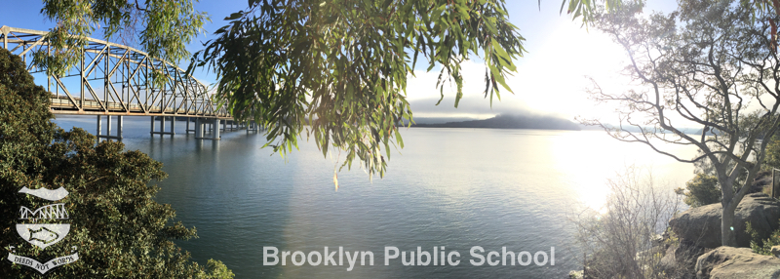
106 Brooklyn Road, Brooklyn, NSW 2083 02 9985 7315 brooklyn-p.school@det.nsw.edu.au

Swimming Scheme 2019

Monday 14 October – Friday 25 October 2019

Dear Parents / Caregivers,

The 2019 Swimming Scheme will be commencing on the first Monday of Term 4, 2019 (14 October) and will run every school day for two weeks.

In line with D of E Policy, our School Swimming Scheme will be running in coordination with the School Sports Unit, and will utilise the Sport Unit’s Swimming Teachers at Abbotsleigh Pool. The program is run for students in

Years 2-5 only.

Where: Abbotsleigh Swimming Pool

When: October 14 - October 25. (10 Consecutive Days in total)

Time: Leaving BPS at 11:00am. Returning to BPS by 2:15pm.

Travel: Bus – Subsidised by the BPS P&C

Cost: $120

What to Bring: In a small bag: A towel, sunscreen and underwear to change into after the session. Students will eat their recess as normal at school before departing, and will eat lunch at Abbotsleigh before returning on the bus. Please do not place a lunch order for the weeks your child(ren) are attending swimming.

What to wear: Sports uniform, including hats and shoes (not sandals). Students should come to school wearing their swimmers under their uniforms. Students will be provided with a swimming cap which must be brought with them and worn in the pool each day.

Kind Regards,

Diana Aitken Paul Teunis

Principal Swimming Coordinator

